**Assignment 7**

**Name: Mudit Mohit**

**Enrolment No.: BT21GCS057**

**Section: B2**

**Question:**

**Write a program to sort an array of integers using the Heap Sort. Analyze your program over the following conditions:**

**1. List is in sorted order**

**2. List is in unsorted order**

**3. What is the best-case and worst-case complexity of a program?**

**4.** **Compare the performance of heap sort with merge sort and quick sort.**

Ans:

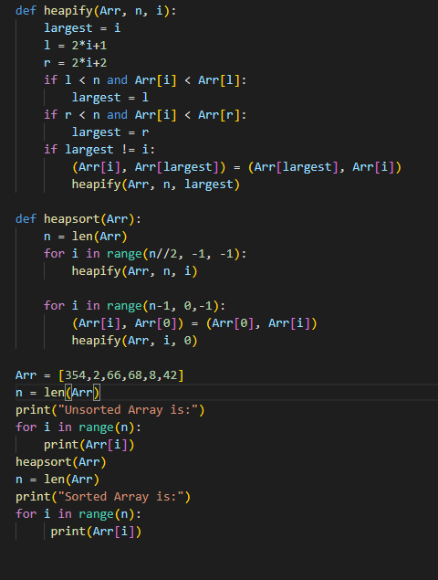

Output:

2) List is in Unsorted order:

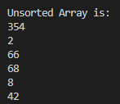

1. List is in Sorted order:

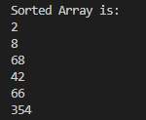

3.) Best case complexity: n*log(n)

Worst case complexity: n*log(n)

4.) Heap sort is the shortest algorithm than merge sort and quick sort. As they require recursion which is not required in heap sort. Heap sort requires less memory than merge sort and quick sort.